Results after running “Sub Ticker_Volumes_Hard_Workbook()”

2016 Results

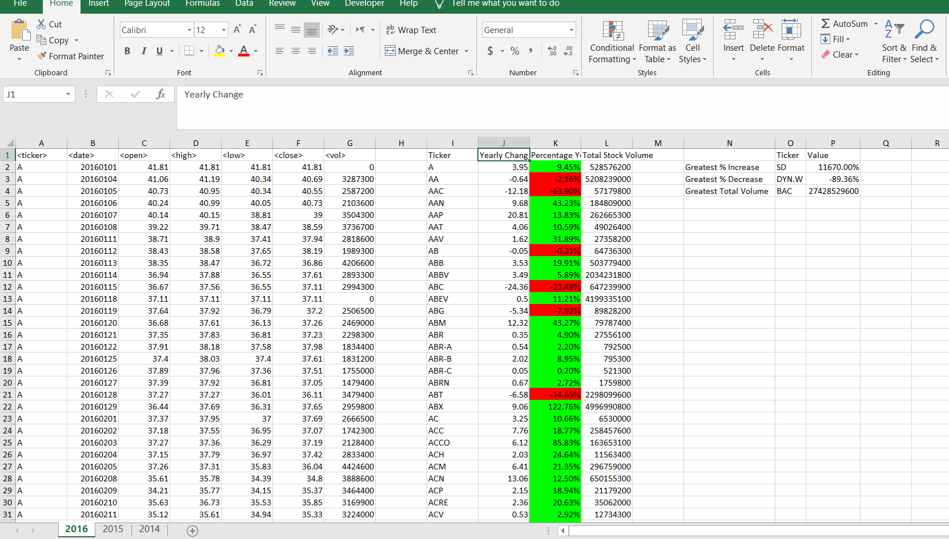

2015 Results

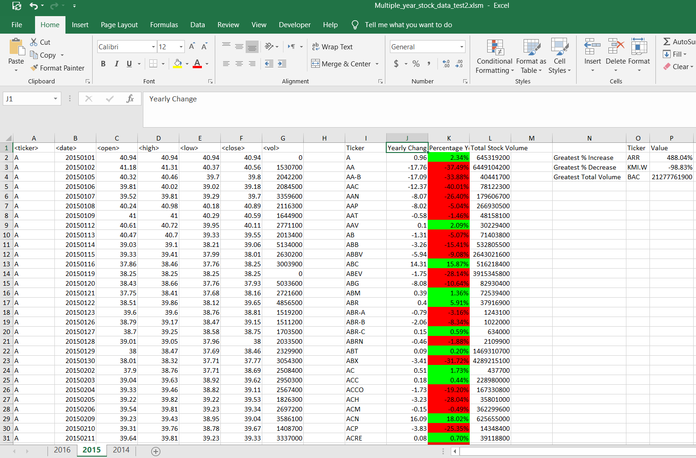

2014 Results

